Neo6502

|  |  |
| --- | --- |
| **OLIMEX Ltd.** 2 Pravda St., P.O. Box 237, Plovdiv 4000 BULGARIA | **Contact:** Mr. Tsvetan Usunov **Email:** [info@olimex.com](mailto:info@olimex.com) **Voice:** +359-32-626259, +359-32-267407, +359-32-621270 |

# Welcome – please read!

Welcome to the modern retro computer world, where you can experience the technology from the 70s and 80s, but with a modern spin on it!

This document covers both the Neo6502 and Neo6502pc computer. Detailed specifications and the differences between the two can be found in Appendix A.

|  |
| --- |
| Neither of the devices (the Neo6502 and Neo6502pc) are turn-key solutions. Both devices require intermediate electronics and computer use knowledge. While both devices have appeared in social media as an out-of-the-box video game platform, it will require that you read this document, so that you gain the best experience! |

## Please Note

Regardless of the function you are hoping to utilize the Neo6502 or Neo6502pc, you must be familiar with the process of reprogramming (also known as flashing firmware) the 2MB flash memory utilized by the RP2040. The firmware defines what function the Neo6502 or Neo6502pc will perform. Current firmware available provide a BASIC interpreter (NeoBASIC) that is continues to be developed and improved, an Apple ][ emulator (using the real W6502), and an Oric Atoms. Other firmware is currently being developed, so explore the various user forums, Discord, and Facebook to discover the endless possibilities of the Neo6502 and Neo6502.

**Please read the Programming the RP2040 Section (page 5)**

Both devices require that you obtain or supply the following for proper operation:

**Neo6502**

* USB-C Power Source (5v, 0.2 amps).
* A USB cable with a USB-A on one end, and the appropriate end that will connect to your computer *(used to re-program the RP2040)*.
* *Optional,* enclosing case for the Neo6502, *available from Olimex.*
* *Optional*, USB-A Flash Drive (*highly recommend USB3, ~8 GB*).
* *Optional*, USB Hub (*Olimex USB-NeoHub is highly recommended for compatibility*).

**Neo6502pc**

* USB-C Power Source (5v, 1 amp).
* A USB cable with a USB-C on one end, and the appropriate end that will connect to your computer.
* USB-A Flash Drive (highly recommend USB3, ~8 GB).
* USB Keyboard *(wired and wireless w/USB dongle are supported).*
* *Optional,* USB Gamepad.

# Table of Contents

Welcome – please read! 2

Please Note 2

Table of Contents 3

About the Neo6502 4

Programming the RP2040 5

Prerequisites 5

RP2040 programming for the Neo6502 5

RP2040 programming for the Neo6502pc 6

Current Firmware 7

NeoBasic (codename: Morpheus) 7

[Apple ] and //e Emulation 7

[Apple ] TotalReplay 8

Oric Atmos 8

Appendix A 9

Neo6502 10

Hardware Pictures 10

Neo6502pc 12

Features 12

Hardware Pictures 13

Neo6502pc Specific Hardware Specifications 15

Neo6502pc – Schematic 15

Neo6502pc – 12 GPIO EXT1 Connector 15

Shared Hardware 16

Neo6502pc and Neo6502 – W6502 Bus Connector 16

Neo6502pc and Neo6502 – UEXT Connectors 17

Neo6502pc and Neo6502 – Configuration Switch Block 18

Appendix B – CREDITS and LICENSE 19

This document initially created by 19

Additional authors and Contributors 19

Included documents (superseding) 19

Note to contributing authors 19

Appendix C – Document Revision History 20

Appendix D – About Olimex 21

# About the Neo6502

The Neo6502 is an open-source hardware and software standalone modern retro computer with a real W65C02 processor and RP2040 co-processor, 2MB of flash memory, and HDMI video out. This small device works 3-times-faster than any of the other recent 6502 competitors and 30-times-faster than 6502 based machines from the 1980s.

The “Neo” name was used two reasons: First it implies a modern design; Second came from the analogy with the movie The Matrix where the W65C02 lives in virtual world – thinking it has real memory, video and keyboard – however in reality it is all virtual and emulated with the RP2040.

Both the Neo6502 and Neo6502pc are open-source hardware (https://freedomdefined.org/OSHW), with all CAD files and firmware and available to support the future development of software and enhancements to the hardware.

More information about the Neo6502 project, please refer to the Neo6502 website (<http://www.neo6502.com>)

# Programming the RP2040

The process of programming the RP2040 is a fairly easy process, *however*, it has a very specific manner and steps that must be followed to have a successful reprogramming.

**NOTES**

* Some emulators require all switches of the configuration switch block be in the on (closed) position.

## Prerequisites

* Your computer should be on, and you must be logged in and have the desktop present. Best experience comes with no CPU intensive tasks running on your computer.
* You have the latest version of the firmware that you want to use downloaded to your computer. *It is highly recommended that you download the firmware file from the “source of truth” (the developer’s Github repository or website).*A firmware file come in various sizes and names, based on the functionality it performs, however it will always have the uf2 file extension.
* Make sure the Neo6502 device has been powered down.

## RP2040 programming for the Neo6502

**Required hardware:**

* A computer with a USB port and a modern operating system.
* A Neo6502 computer.
* A USB cable with a USB-A on one end, and the appropriate end that will connect to your computer.

**Steps:**

1. Connect the USB cable between your computer and the Neo6502 USB-A port. *If you have a USB hub connected or any other device connected to the USB-A port, please disconnect it during this process.*
2. Press and hold the "boot" button (bottom left, with the UEXT port on the left and the W6502 bus on the bottom). *Ensure you have heard or felt the button depress with a satisfying “click”.*
3. Turn the power on.
4. Release the "boot" button.
5. A volume will appear on your computer with the name “RPI-RP2”.
6. Copy the appropriate UF2 file to the “RPI-RP2” volume.
7. **Do not be alarmed**, as soon as the copy is finished, the volume will disappear. *This indicates that the firmware has been successfully uploaded and programming has begun and will only take a few seconds*.
8. Reconnect the USB hub and other devices that were removed on step 1.

## RP2040 programming for the Neo6502pc

**Required hardware:**

* A computer with a USB port and a modern operating system.
* A Neo6502pc computer.
* A USB cable with a USB-C on one end, and the appropriate end that will connect to your computer.

**Steps:**

1. Connect the USB Cable between your computer and the Neo6502 USB-C port (with the LCD facing up, the USB-C port on the left).
2. Slide the programming switch on the back of the Neo6502pc to the programming position (with the switch facing up and in the upper left corner – move to the right-most position).
3. Press and hold the "boot" button (to the left of the programming switch). *Ensure you have heard or felt the button depress with a satisfying “click”.*
4. Continue to press the “boot” button and turn the power on.
5. Release the "boot" button.
6. A volume will appear on your computer with the name “RPI-RP2”.
7. Copy the appropriate UF2 file to the “RPI-RP2” volume.
8. **Do not be alarmed**, as soon as the copy is finished, the volume will disappear. *This indicates that the firmware has been successfully uploaded and programming has begun and will only take a few seconds*. The Neo6502pc will automatically reboot using the new firmware.
9. Move the programming switch back to “run” position.

**SUCCESS**

Based on the firmware that was just flashed, the Neo6502pc will now operate within the firmware function. Please refer to the documentation that comes with the firmware to know the next steps. The most popular firmware and their next steps are provided in this document.

### Troubleshooting

* If you are using a Neo6502pc, ensure the programming switch in in the “program” position.

# Current Firmware

The following are accurate as of the August 4th, 2024 revision of this document.

## NeoBasic (codename: Morpheus)

Maintained by Paul Robson (paul@robsons.org.uk)

GitHub Repository: <https://github.com/paulscottrobson/neo6502-firmware>

Obtain the firmware from the repository link

1. A screen shot of a computer

   Description automatically generatedWithin the Github respository, navigate to the releases section (right side)
2. Click on the link (release number). This will take you to the releases list.
3. Locate and click the zip file to download it.
4. Unzip the file.
5. Locate the “firmware_usb.uf2” file.   
   *The “*firmware_sd.uf2*” file is used when you are using the SDCard adapter.*
6. Follow the directions above to program the RP2040 on page 4.

Please refer to the NeoBasic section for more information.

## A blue screen with white text Description automatically generatedApple ][ and //e Emulation

Maintained by Veselin Sladkov (veselin.sladkov@gmail.com)

Obtain the firmware from: <https://github.com/vsladkov/reload-emulator>

The firmware source code is found on the repository; however, it is not compiled into a uf2 file. You can download the uf2 firmware file from Olimex’s FTP site: <https://ftp.olimex.com/Neo6502/>

1. Click the link to open the Olimex FTP site.
2. Click and download the “blank_disk_for_apple2e_code_development_apple2e_ProDOS_2_4_3.zip” file.
3. Unzip it, and copy the “ProDOS_2_4_3.po” to a flash drive.
4. Follow the directions above to program the RP2040 on page 4, with the “apple2e.uf2” file.

You can replace the “ProDOS_2_4_3.po” with other disk images that can be found on the internet. Check out the Apple ][ section on the Internet Archive (<https://archive.org/details/softwarelibrary_apple_games>) as well as other locations.

## Apple ][ TotalReplay

Maintained by Veselin Sladkov (veselin.sladkov@gmail.com)

Obtain the firmware from: <https://github.com/vsladkov/reload-emulator>

The firmware source code is found on the repository; however, it is not compiled into a uf2 file. You can download the uf2 firmware file from Olimex’s FTP site: <https://ftp.olimex.com/Neo6502/>

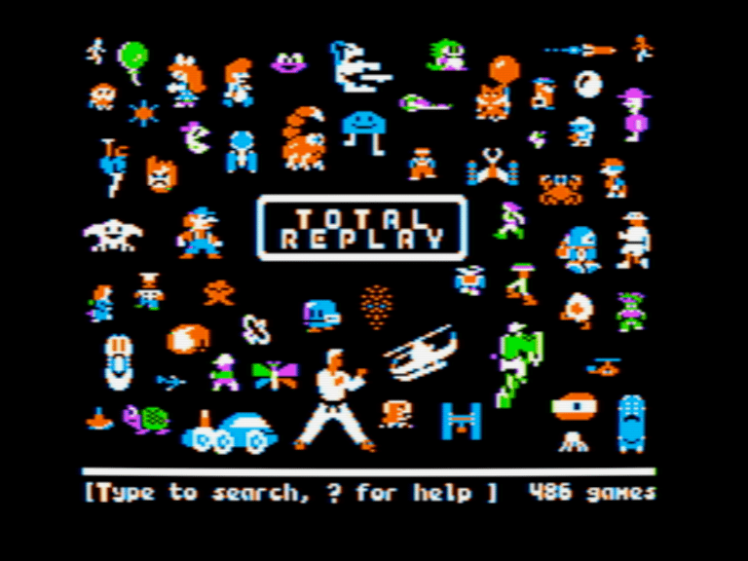

1. Click the link to open the Olimex FTP site.
2. Click and download two files:

* “Total Replay v5.1.hdv” file.
* “apple2e-5.uf2” file.

1. Copy the “Total Replay v5.1.hdv” to a flash drive.
2. Follow the directions above to program the RP2040 on page 4, with the “apple2e-5.uf2” file.

If successful, turning on the Neo6502 device, will present you with the TotalReplay title screen. All games can be played with a keyboard and some games support the USB gamepad, your milage by vary.

## A screen with a white screen Description automatically generatedOric Atmos

Maintained by Veselin Sladkov (veselin.sladkov@gmail.com)

Obtain the firmware from: <https://github.com/vsladkov/reload-emulator>

The firmware source code is found on the repository; however, it is not compiled into a uf2 file.

You can download the uf2 firmware file from Olimex’s FTP site: <https://ftp.olimex.com/Neo6502/uf2/oric_960x540_372MHz.uf2>

This is an older version, and no compiled version updated firmware is available as a download, as you must have copies of the Oric ROMs. You will need to compile it yourself or ask folks on social media if a updated compiled version is available.

# NeoBASIC Technical Reference

This is a reference for Neo6502's BASIC interpreter. Many BASIC commands are just wrappers of specific API functions.

## Binary Operators

|  |  |  |
| --- | --- | --- |
| Precedence | Operator | Notes |
| 4 | * | Multiplication operator |
| 4 | / | Forward slash is floating point divide. 22/7 is 3.142857 |
| 4 | \ | Backward slash is integer divide, 22\7 is 3 |
| 4 | % | Modulus of integer division ignoring signs |
| 4 | >> | Logical shift right, highest bit zero |
| 4 | << | Logical shift left |
| 3 | + | Addition operator |
| 3 | - | Subtraction operator |
| 2 | < | Return -1 for true, 0 for false |
| 2 | <= | Return -1 for true, 0 for false |
| 2 | > | Return -1 for true, 0 for false |
| 2 | >= | Return -1 for true, 0 for false |
| 2 | <> | Return -1 for true, 0 for false |
| 2 | = | Return -1 for true, 0 for false |
| 1 | & | Binary AND operator on integers |
| 1 | | | Binary OR operator on integers |
| 1 | ^ | Binary XOR operator on integers |

## Arithmetic and Boolean Functions

|  |  |
| --- | --- |
| Operator | Description (*function and return value)* |
| atan(n) | Arctangent of n in degrees | |
| atan2(y,x) | Arctangent 2 calculation, dy / dx => angle | |
| cos(n) | Cosine of n, n Is in degrees. | |
| exp(n) | e to the power n | |
| FALSE | Return constant 0, improves boolean readability | |
| int(n) | Whole part of the float value n. Integers are unchanged. | |
| log(n) | Natural Logarithm (e.g. ln2) of n. | |
| max(a,b) | Return the largest of a and b (numbers or strings) | |
| min(a,b) | Return the smaller of a and b (numbers or strings) | |
| pow(a,b) | Returns a raised to the power b ; the result is always floating point. | |
| rand(n) | Random integer 0 { x { n (e.g. 0 to n-1) | |
| rnd(n) | Random number 0 { x { 1, ignores n. | |
| sin(n) | Sine of n, n Is in degrees. | |
| sqr(n) | Square root of n | |
| tan(n) | Tangent of n, n Is in degrees. | |
| TRUE | Return constant -1, improves boolean readability | |

## File System Functions

|  |  |
| --- | --- |
| Operator | Description (*function and return value)* |
| eof(f) | Returns non-zero value if at end of file f. | |
| exists(file$) | Returns true (-1) if the file exists, false (0) otherwise | |
| locale a$ | Sets the locale to the 2 character country code a$ e.g. locale "de" | |
| mos(command) | Like the mos command, but returns an non zero error code if the command caused an error. | |

## BASIC Interpreter Functions

|  |  |
| --- | --- |
| Operator | Description (*function and return value)* |
| err | Current error number | |
| erl | Current error line number | |

## String Functions

|  |  |
| --- | --- |
| Operator | Description (*function and return value)* |
| asc(s$) | Return ASCII value of first character or zero for empty string | |
| chr$(n) | Convert ASCII to string | |
| instr(str$,search$) | Returns the first position of search$ in str$, indexed from 1. Returns zero if not found. | |
| isval(s$) | Converts string to number, returns -1 if okay, 0 if fails. | |
| left$(a$,n) | Left most n characters of a$ | |
| len(a$) | Return length of string in characters. | |
| lower$(a$) | Convert a string to lower case | |
| mid$(a$,f[,s]) | Characters from a$ starting at f (1 indexed), s characters, s is optional and defaults to the rest of the line. | |
| right$(a$,n) | Rightmost n characters of a$ | |
| spc(n) | Returns a string of n spaces. | |
| str$(n) | Convert n to a string | |
| upper$(a$) | Convert a string to upper case | |
| val(s$) | Convert string to number. Error if bad number. | |

## Hardware Information Functions

|  |  |
| --- | --- |
| Operator | Description (*function and return value)* |
| alloc(n) | Allocate n bytes of memory, return address | |
| analog(n) | Read voltage level on pin n -- returns a value from 0 to 4095 | |
| deek(a) | Read word value at a | |
| havemouse() | Return non zero if a mouse is connected. | |
| himem | First byte after end of memory -- the stack is allocated below here, and string memory below that. | |
| inkey$() | Return the key stroke if one is in the keyboard buffer, otherwise returns a n empty string. | |
| idevice(device) | Returns true if i2c device present. | |
| iread(device,register) | Read byte from I2C Device Register | |
| joycount() | Read the number of attached joypads, not including keyboard emulation of one. | |
| joypad([index],dx,dy) | Reads the current joypad. The return value has bit 0 set if A is pressed, bit 1 set if B is pressed. Values -1,0 or 1 are placed into dx,dy representing movement on the D-Pad. If there is no gamepad plugged in (at the time of writing it doesn't work) the key equivalents are WASDOP and the cursor keys. If [index] is provided it is a specific joypad (from 1,0 is the keyboard), otherwise it is a composite of all of them. | |
| key(n) | Return the state of the given key. The key is the USB HID key scan code. | |
| mouse(x,y[,scroll]) | Reads the mouse. The return value indicates button state (bit 0 left, bit 1 right), and the mouse position and also the scrolling wheel position are updated into the given variables. | |
| notes(c) | Return the number of notes outstanding on channel c including the one currently playing -- so will be zero when the channel goes silent. | |
| page | Return the address of the program base (e.g. the variable table) | |
| peek(a) | Read byte value at a | |
| pin(n) | Return value on UEXT pin n if input, output latch value if output. | |
| point(x,y) | Read the screen pixel at coordinates x,y. This is graphics data only. | |
| spoint(x,y) | Reads the colour index on the sprite layer. 0 is transparency | |
| tab(n) | Advance to screen column n if not past it already. | |
| time() | Return time since power on in 100^th^ of a seconds. | |
| uhasdata() | Return true if there is data in the UART Receive buffer. | |
| vblanks() | Return the number of vblanks since power on. This is updated at the start of the vblank period. | |

## UNKNOWN Functions

|  |  |
| --- | --- |
| Operator | Description (*function and return value)* |
| event(v,r) | event takes an integer variable and a fire rate (r) in 1/100 s, and uses the integer variable to return -1 at that rate. If the value in 'v' is zero, it resets (if you pause say), if the value in v is -1 the timer will not fire -- to unfreeze, set it to zero and it will resynchronise. | |
|  |  | |

# Appendix A

This appendix offers the detailed specifications for each of the Neo6502 computers and the differences between them.

|  |  |  |
| --- | --- | --- |
| Feature | Neo6502  Computer | Neo6502pc Computer |
| Physical W65C02 processor running at 6.25Mhz | Yes | Yes |
| RP2040 SoC (System on a Chip) w/ 2MB Flash | Yes | Yes |
| 10-pin UEXT connector | 1x | 4x |
| 6502 bus connector | Yes | Yes |
| Audio mini speaker | Yes | Yes |
| Audio 3.5mm connector | Yes | Yes |
| USB-C power supply connector | Yes | Yes |
| DVI/HDMI connector | Yes | No[1] |
| USB-A Port[2] | 1x[3] | 3x |
| 4-position configuration slide switch | Yes | Yes |
| Boot Button | Yes | Yes |
| One 14-pin external 12 GPIO connector | No | Yes |
| Programming slide switch | No | Yes |
| USB-C Programming Port | No | Yes |
| Build-in LCD display w/ touch panel acting like mouse | No | Yes |
| Build in LiPo battery w/ charger circuit and battery monitoring | No | Yes |
| Power on off switch | No | Yes |

## A red circuit board with black and red components Description automatically generatedNeo6502

The Olimex Neo6502 was the first model released. The main components are a W65C02 and a Raspberry Pi RP2040. The W65C02 runs the machine code (at about 6.3Mhz), with the RP2040 providing RAM, Video and other aspects.

Early adopters had a revision A board (purple), and later the revision B board (red) was released. Both are almost identical, with the exception that the revision A board required a couple of wires connecting pins of the UEXT to the 6502 bus to work properly. Both models come as the board only, with cases available to protect the board.

### Hardware Pictures

## Neo6502pc

The Olimex Neo6502pc is an open-source hardware and software standalone modern retro computer with a real W65C02 processor, RP2040 co-processor, USB host (with 3x USB-A ports), Lipo battery with charger circuit and battery monitoring.

The design goal with Neo6502pc was to create a simple retro-computer with a real 6502 processor that has modern features (provided by the Raspberry RP2040 co-processor) such as HDMI video output, USB ports that support USB keyboards, flash drives for storage, and USB game pad. The RP2040 co-processor emulates the RAM for the W6502 processor.

More Information: <https://www.olimex.com/Products/Retro-Computers/Neo6502pc/open-source-hardware>

## Features

* A real W65C02 processor clocked at 6.25Mhz
* Graphics co-processor RP2040 providing 320 x 240 resolution with 256-color display on HDMI/DVI.
* 32k Graphics RAM for tiles and sprites
* 128 sprites up to 32x32 pixels.
* Multiple tile maps (16x16 tiles, can be double sized)
* High speed drawing features
* Turtle Graphics
* Blitter for high-speed graphics
* Four UEXT interface ports to access a wide range of hardware add ons.
* 1 channel "beeper" sound with SFX library (to be replaced by AY-3-8910 Emulation)
* USB flash drive support for storage w/ optional SD Card support.
* Supports standard USB keyboard.
* Fast structured BASIC with hardware support and inline assembler.
* BASIC can be edited on screen or using a text editor.
* High Speed Integer/Floating point arithmetic
* Huge open-source community that has written documentation, provided samples, and code including games.
* Cross development support
* Accurate cross platform emulator for Windows/Mac/Linux, only requires SDL2
* Serial link to PC for Cross-Development
* Program in PASCAL using Mad Pascal compiler
* Program in 'C' using CC65 and LLVM
* USB Mouse and Gamepad support
* BASIC support for Serial, I2C and SPI hardware via UEXT Connector - 64KB linear RAM space for code
* LCD display
* Internal battery backup power supply which allows it to operate up to 3 hours without external power supply
* Three external and one internal USB hosts (internal is connected to LCD touch panel)
* Audio output
* 12 GPIO extension connector
* USB-C for power and internal battery charging.
* Second USB-C for RP2040 firmware programming
* Dimensions 220 x 130 x 35 mm

### Hardware Pictures

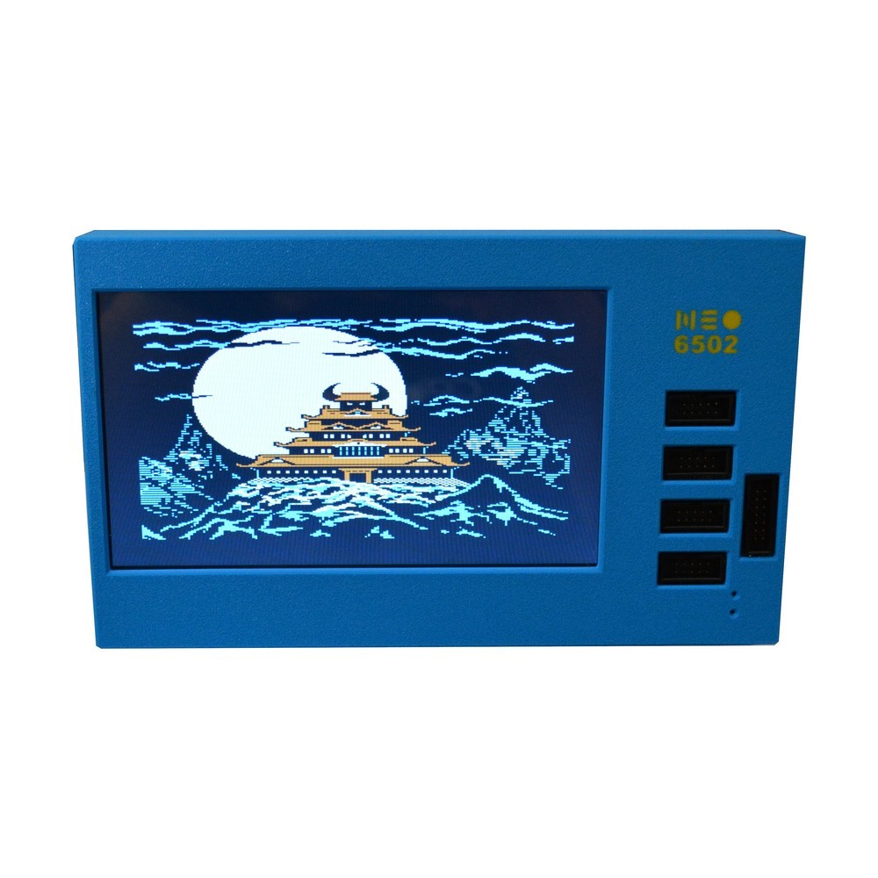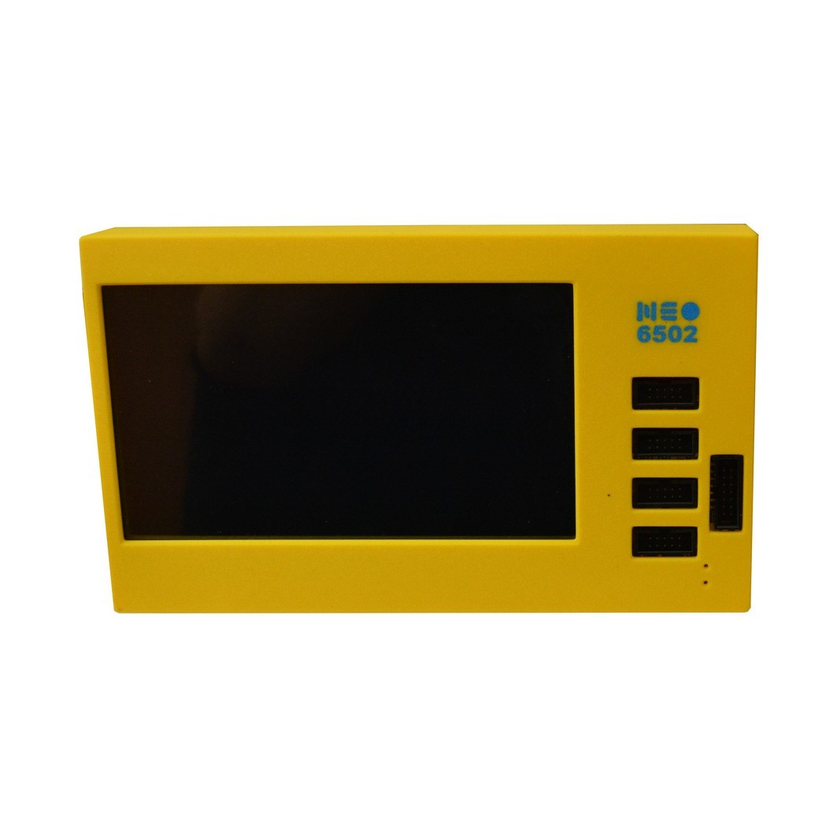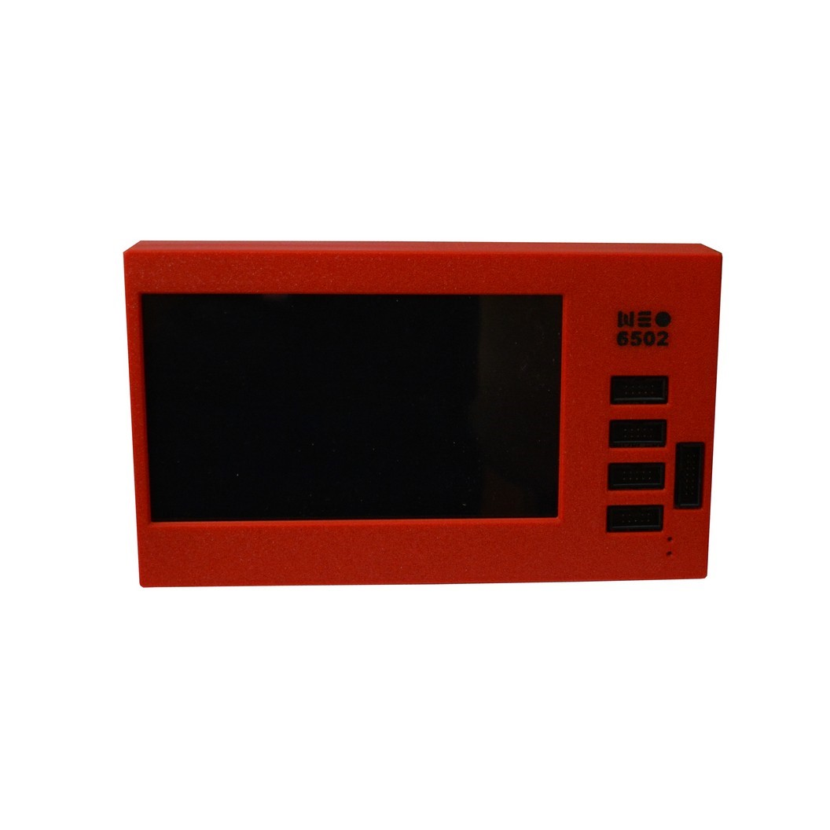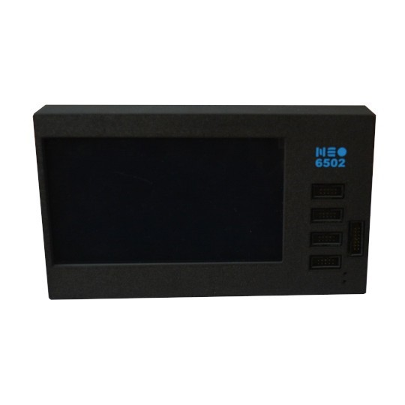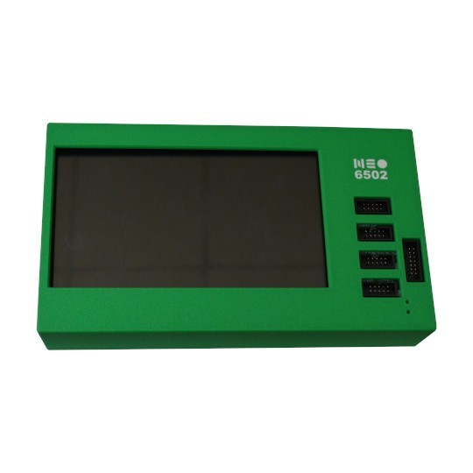

## Neo6502pc Specific Hardware Specifications

### Neo6502pc – Schematic

The latest schematic for the Neo6502pc is available on GitHub using this link: <https://github.com/OLIMEX/Neo6502pc>

### Neo6502pc – 12 GPIO EXT1 Connector

Neo6502pc has a CH32V003 expander IC which is connected to RP2040 via I2C and can monitor battery charge, the presence of the external power supply and access to the 12 GPIOs via the EXT1 connector:

|  |
| --- |
|  |
| Neo6502pc and Neo6502 – 12-pin GPIO EXT1 connector schematic |

# Shared Hardware

## Neo6502pc and Neo6502 – W6502 Bus Connector

All 6502 signals are available on BUS1 connector for attaching external hardware on it. Signals available:

* +5V
* 3.3V
* GND
* D0-D7
* A0-A15
* PHI2
* R/W
* RESB
* SOB
* MLB
* VPB
* SYNC
* NMIB
* IRQB

Two signals of RP2040 SWDIO and SWCLK are also present for RP2040 debugging, these should not be connected on the external 6502 peripheral boards.

|  |
| --- |
|  |
| Neo6502pc and Neo6502 – W6502 bus connector schematic |

### Neo6502pc and Neo6502 – UEXT Connectors

UEXT (Universal EXTension) connectors have the following signals available. All signals are with 3.3V levels.

* +3.3V
* GND
* I2C
* SPI
* UART

UEXT connector can be found in many different shapes, however the connector used on the Neo6502pv uses a UEXT connector that is 0.1” 2.54mm step boxed plastic connector.

|  |
| --- |
|  |
| Neo6502 and Neo6502pc UEXT Connector w/signal identification |

Olimex has developed number of [MODULES](https://www.olimex.com/Products/Modules/) with this connector: temperature, humidity, pressure, magnetic field, light sensors, LCDs, LED matrix, Relays, Bluetooth, Zigbee, WiFi, GSM, GPS, RFID, RTC, EKG, sensors and etc.

Neo6502pc UEXT connector is wired to RP2040 GPIOs as follows:

|  |
| --- |
|  |
| Neo6502 and Neo6502pc UEXT schematic |

### Neo6502pc and Neo6502 – Configuration Switch Block

The Slide configuration switch can enable/disable the Buzzer, also can connect or disconnect RESB, NMIB and IRQB to RP2040 UEXT signals.

|  |
| --- |
|  |
| Neo6502 and Neo6502pc configuration switch block schematic |

By default, the Neo6502pc is shipped with all switches in the closed state – enabling the Piezoelectric Buzzer Speaker, and all signals wired to the RP2040. With SW2, SW3 and SW4 enabled, the SPI on UEXT cannot be used.

# Appendix B – CREDITS and LICENSE

The Neo6502 board, schematics, and firmware are all part of an Open Source project created by Mr. Tsvetan Usunov of Bulgaria.

This document is an open-source copy-left document that is a collection and combination of various other open-source documents and is meant to be a superset of these documents and replaces them. Permission is hereby granted, free of charge, to any person obtaining a copy of these documentation files (the "Software"), to deal in the Software without restriction, including without limitation the rights to use, copy, modify, merge, publish, distribute, sublicense, and/or sell copies of the Software, and to permit persons to whom the Software is furnished to do so, subject to the following conditions:

* All derivatives of this document must also carry the same open-source copy-left license.

THE SOFTWARE IS PROVIDED "AS IS", WITHOUT WARRANTY OF ANY KIND, EXPRESS OR

IMPLIED, INCLUDING BUT NOT LIMITED TO THE WARRANTIES OF MERCHANTABILITY,

FITNESS FOR A PARTICULAR PURPOSE AND NONINFRINGEMENT. IN NO EVENT SHALL THE

AUTHORS OR COPYRIGHT HOLDERS BE LIABLE FOR ANY CLAIM, DAMAGES OR OTHER

LIABILITY, WHETHER IN AN ACTION OF CONTRACT, TORT OR OTHERWISE, ARISING FROM,

OUT OF OR IN CONNECTION WITH THE SOFTWARE OR THE USE OR OTHER DEALINGS IN THE

SOFTWARE.

**This license can also be found in the Github repository:**  
https://github.com/jewettg/Neo6502-Documentation/blob/main/LICENSE.md

**This document initially created by**

**Greg Jewett**  
**Email:** greg(at)ejewett(dot)com  
**Website:** <https://sites.google.com/ejewett.com/gregjewett/home>

For a list of contributing authors and updates, please visit the Github repository:

https://github.com/jewettg/Neo6502-Documentation/blob/main/CONTRIBUTING.md

# Appendix C – Document Revision History

Please visit the GitHub repository file CHANGELOG.md

<https://github.com/jewettg/Neo6502-Documentation/blob/main/CHANGELOG.md>

# Appendix D – About Olimex

|  |  |
| --- | --- |
| **OLIMEX Ltd.** 2 Pravda St., P.O. Box 237, Plovdiv 4000 BULGARIA | **Contact:** Mr. Tsvetan Usunov **Email:** [info@olimex.com](mailto:info@olimex.com) **Voice:** +359-32-626259, +359-32-267407, +359-32-621270 |

Olimex Ltd is a leading provider for development tools and programmers for embedded market.

The company has 28 years of experience in designing, prototyping and manufacturing printed circuit boards, sub-assemblies, and complete electronic products.

We were established in 1991 in Plovdiv - the second largest city in Bulgaria.

We have extensive knowledge in analog, digital, and microcontroller design, and we offer our own-designed development boards, programmers and emulators for rapid prototyping ARM, AVR, MSP430, MAXQ and PIC microcontrollers.

Olimex is recognized as an approved third-party hardware developer by Texas Instruments Inc., Maxim Integrated, Atmel Inc., NXP Inc., ST Microelectronics Inc., IAR Systems AB, Cirrus Logic Inc., OKI Semiconductor Inc, Energy Micro Inc., and Microchip Inc.

We have over 30,000 active customer accounts who regularly use our services for electronic boards development and prototyping. Our design capabilities are backed by our own PCB prototype production and assembly facility, so all designs made by us are created with design-for-manufacturing in mind - which guarantees that they are optimized for reliability and provide cost-effective solutions for our customers.

The company’s 5,000 sq m. production buildings are situated on our 10,000 sq m. property.

1. The HDMI port is utilized by the built-in LCD display.
2. The USB-A port can be used for various USB accessories (keyboards, flash drives, gamepad, etc..) and for the Neo6502 – it serves as the RP2040 programming port (*requires a USB-A to USB-A cable*).
3. Requires the USB-Neohub (https://www.olimex.com/Products/USB-Modules/USB-NeoHub/open-source-hardware) the expand the number of USB-A ports available. Additional ports are required to utilize NeoBasic, as you need at minimum a flash drive and keyboard. *Unlike the USB-Neohub, not all USB hubs are compatible or supported*.